# WEEK – 5 ( WEB API AND MICROSERVICES)

1. **CREATE A CHAT APPLICATION WHICH USES KAFKA AS A STREAMING PLATFORM AND CONSUME THE CHAT MESSAGES IN THE COMMAND PROMPT**.

**Step 1 : install kafka and save it in a folder**

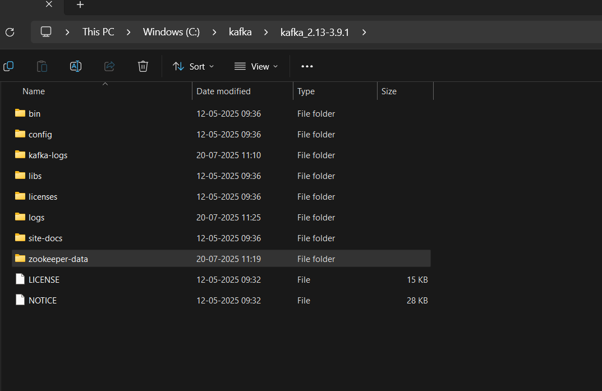

**Step 2:**

**Configure the below two files**

1. **Server.properties**
2. **Zookeeper.properties**

**Path : C: kafka\config\ zookeeper**

*Note : we need to create the folders server-logs and zookeeper-data in kafka main folder for storing the logs of messages and texts*

**Step 3:**

**Initiate the zookeeper properties by below command**



**Step 4:**

**Initiate the server by the below command**



**Step 5 : create the topics for intiating chats**

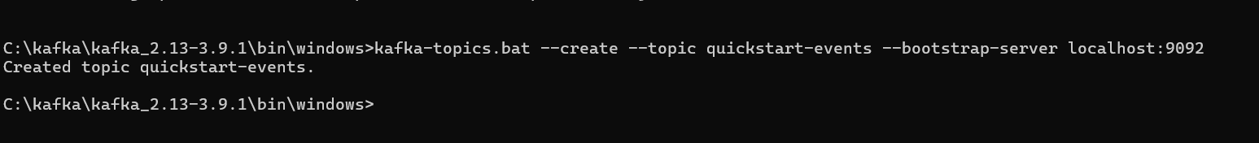

Step 6 : create and initiate the producer programmer

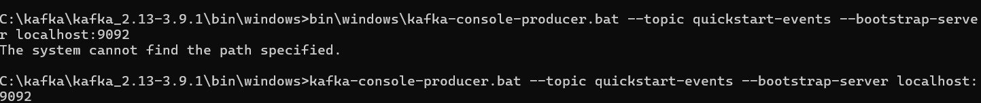

Step 7 : create and initiate the consumer program



Step 8 : the output of chat using kafka and producing and consuming messages through command prompt

Producer :

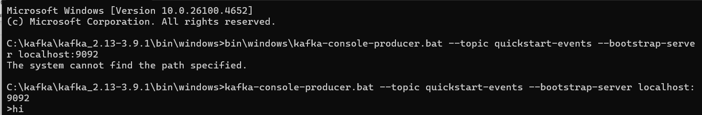

Consumer :

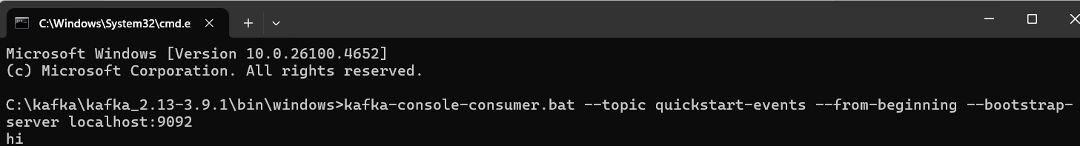

Producer :

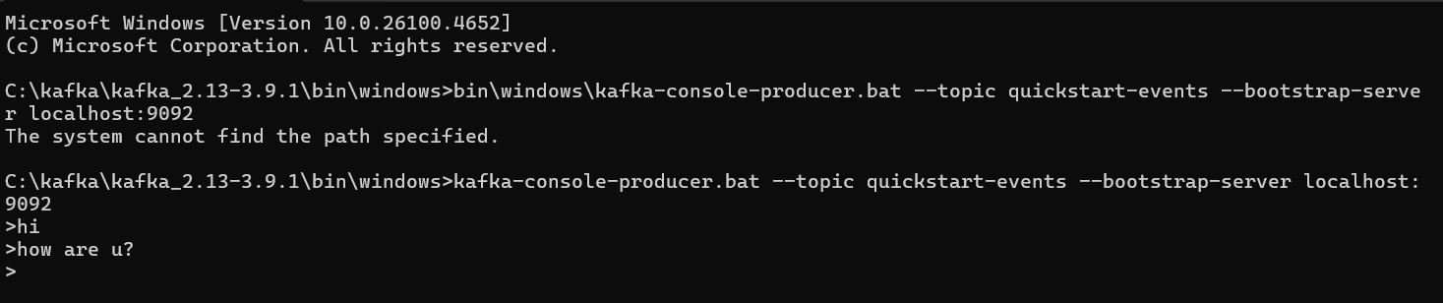

Consumer :

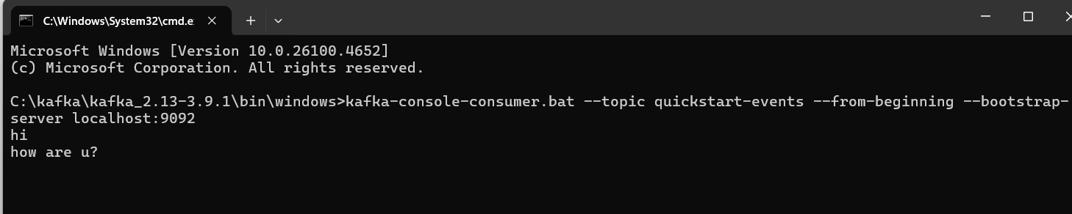

**2) CREATE A CHAT APPLICATION USING C# WINDOWS APPLICATION USING KAFKA AND CONSUME THE MESSAGE IN DIFFERENT CLIENT APPLICATIONS.**

**First create an Web Windows App in Visual studio code**

**Then name the project kafka-chat-application**

**Create a form**

**Form1.cs**

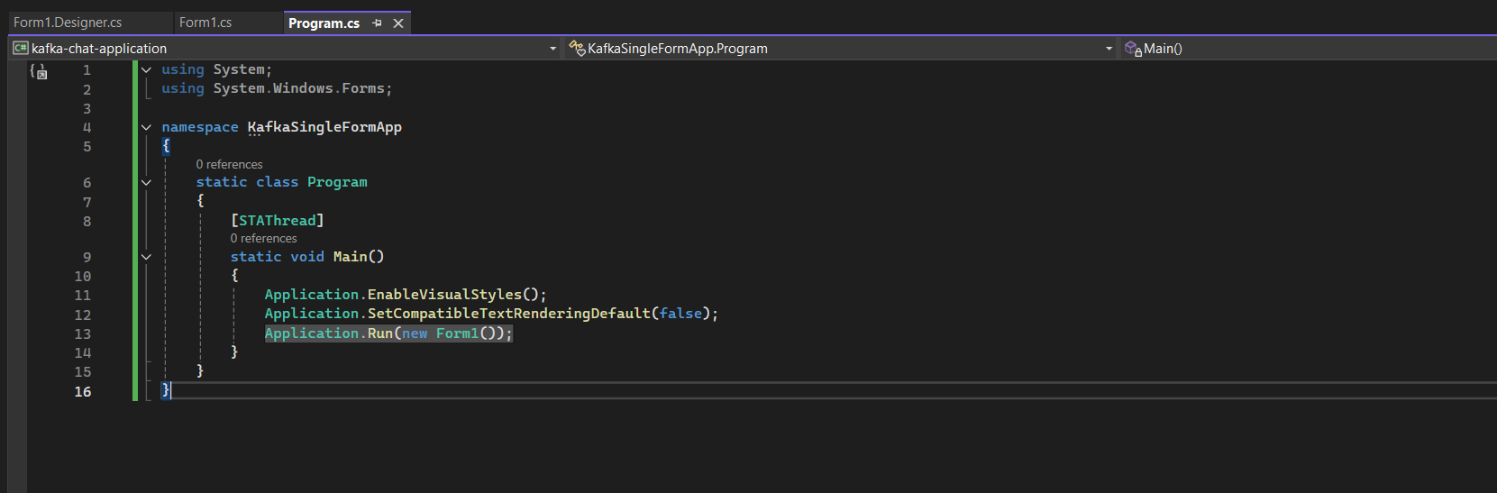

**Form.designer.cs**

*namespace KafkaSingleFormApp*

*{*

*partial class Form1*

*{*

*private System.ComponentModel.IContainer components = null;*

*protected override void Dispose(bool disposing)*

*{*

*if (disposing && (components != null))*

*{*

*components.Dispose();*

*}*

*base.Dispose(disposing);*

*}*

*private void InitializeComponent()*

*{*

*this.txtMessage = new System.Windows.Forms.TextBox();*

*this.btnSend = new System.Windows.Forms.Button();*

*this.lstMessages = new System.Windows.Forms.ListBox();*

*this.txtUsername = new System.Windows.Forms.TextBox();*

*this.label1 = new System.Windows.Forms.Label();*

*this.label2 = new System.Windows.Forms.Label();*

*this.btnStartConsumer = new System.Windows.Forms.Button();*

*this.SuspendLayout();*

*// txtMessage*

*this.txtMessage.Location = new System.Drawing.Point(85, 41);*

*this.txtMessage.Multiline = true;*

*this.txtMessage.Name = "txtMessage";*

*this.txtMessage.Size = new System.Drawing.Size(300, 80);*

*this.txtMessage.TabIndex = 1;*

*// btnSend*

*this.btnSend.Location = new System.Drawing.Point(391, 41);*

*this.btnSend.Name = "btnSend";*

*this.btnSend.Size = new System.Drawing.Size(75, 80);*

*this.btnSend.TabIndex = 2;*

*this.btnSend.Text = "Send";*

*this.btnSend.Click += new System.EventHandler(this.btnSend_Click);*

*// lstMessages*

*this.lstMessages.FormattingEnabled = true;*

*this.lstMessages.ItemHeight = 15;*

*this.lstMessages.Location = new System.Drawing.Point(12, 127);*

*this.lstMessages.Name = "lstMessages";*

*this.lstMessages.Size = new System.Drawing.Size(454, 214);*

*this.lstMessages.TabIndex = 3;*

*// txtUsername*

*this.txtUsername.Location = new System.Drawing.Point(85, 12);*

*this.txtUsername.Name = "txtUsername";*

*this.txtUsername.Size = new System.Drawing.Size(300, 23);*

*this.txtUsername.TabIndex = 0;*

*// label1*

*this.label1.AutoSize = true;*

*this.label1.Location = new System.Drawing.Point(12, 15);*

*this.label1.Name = "label1";*

*this.label1.Size = new System.Drawing.Size(63, 15);*

*this.label1.Text = "Username:";*

*// label2*

*this.label2.AutoSize = true;*

*this.label2.Location = new System.Drawing.Point(12, 44);*

*this.label2.Name = "label2";*

*this.label2.Size = new System.Drawing.Size(56, 15);*

*this.label2.Text = "Message:";*

*// btnStartConsumer*

*this.btnStartConsumer.Location = new System.Drawing.Point(391, 12);*

*this.btnStartConsumer.Name = "btnStartConsumer";*

*this.btnStartConsumer.Size = new System.Drawing.Size(75, 23);*

*this.btnStartConsumer.TabIndex = 4;*

*this.btnStartConsumer.Text = "Start Consumer";*

*this.btnStartConsumer.Click += new System.EventHandler(this.btnStartConsumer_Click);*

*// Form1*

*this.ClientSize = new System.Drawing.Size(478, 353);*

*this.Controls.Add(this.btnStartConsumer);*

*this.Controls.Add(this.label2);*

*this.Controls.Add(this.label1);*

*this.Controls.Add(this.txtUsername);*

*this.Controls.Add(this.lstMessages);*

*this.Controls.Add(this.btnSend);*

*this.Controls.Add(this.txtMessage);*

*this.Name = "Form1";*

*this.Text = "Kafka Producer/Consumer";*

*this.ResumeLayout(false);*

*this.PerformLayout();*

*}*

*private System.Windows.Forms.TextBox txtMessage;*

*private System.Windows.Forms.Button btnSend;*

*private System.Windows.Forms.ListBox lstMessages;*

*private System.Windows.Forms.TextBox txtUsername;*

*private System.Windows.Forms.Label label1;*

*private System.Windows.Forms.Label label2;*

*private System.Windows.Forms.Button btnStartConsumer;*

*}*

*}*

**Program.cs**

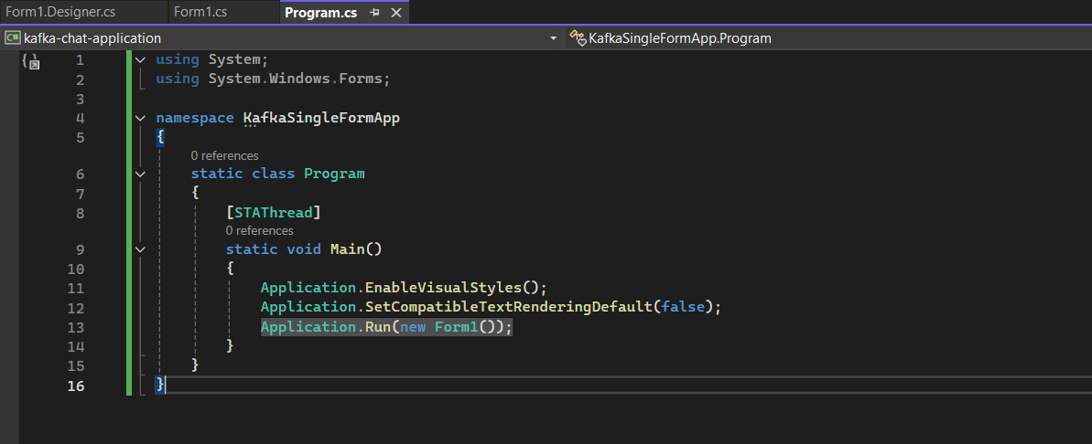

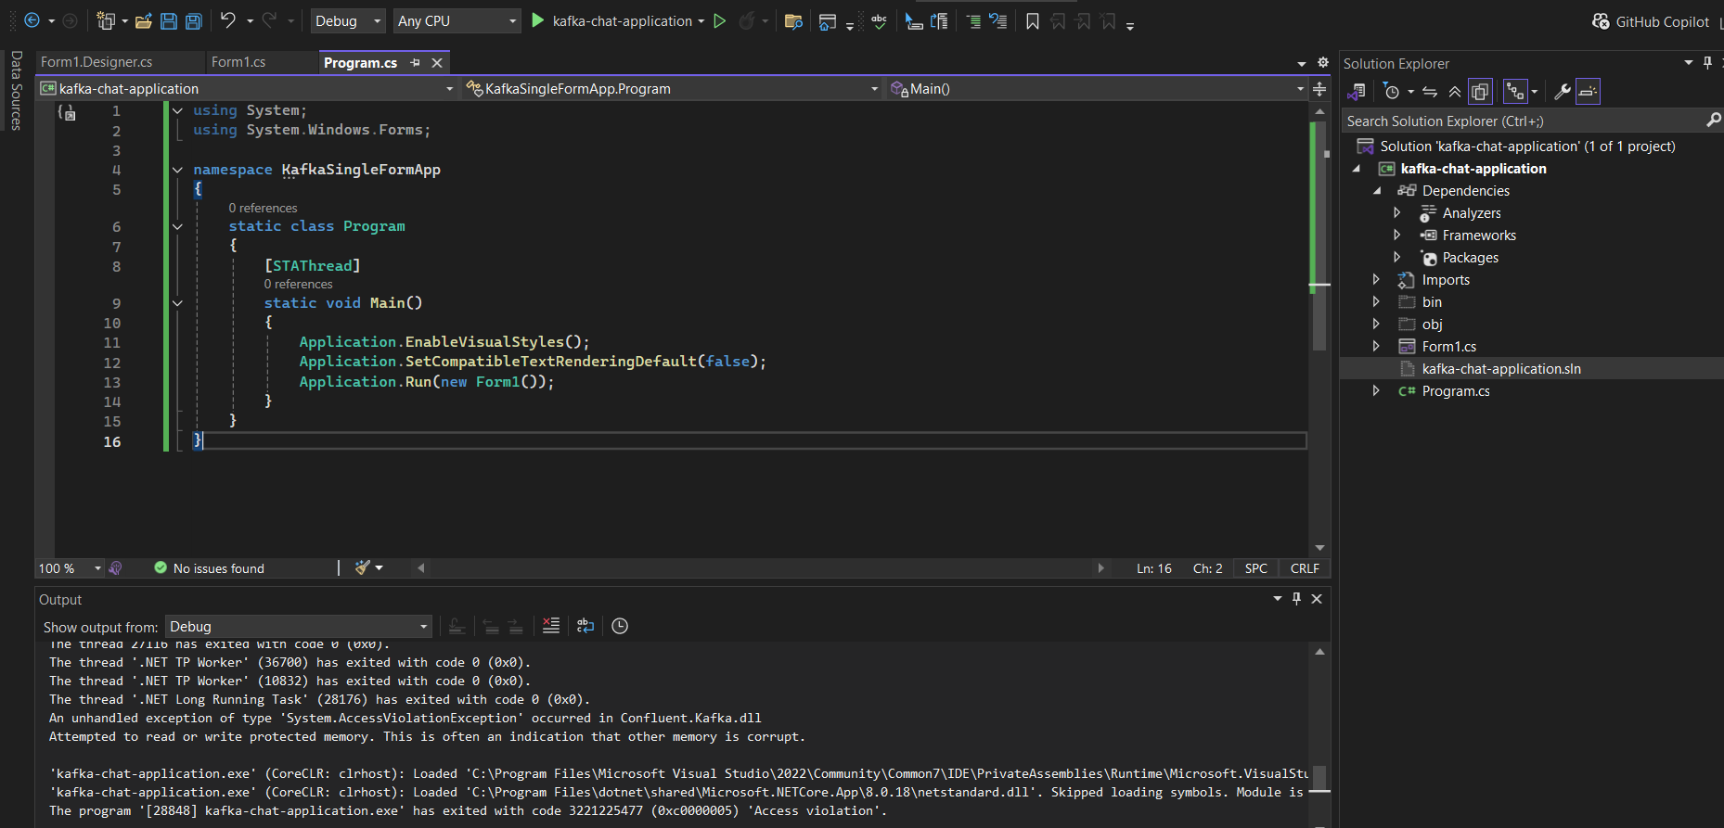

**Above Fig shows the code space for the chat application**

**Output :**

